Bending due to eccentric axial loading in the plane of symmetry
It was shown earlier while discussing the stresses in axially loaded members that the axial normal stress produced will be uniform only if the force acts through the centroid of the cross section. Such loads are called centric loads. If it does not, it is called eccentric load. First, let us consider eccentric axial force acting in the plane of symmetry of the cross section.
In such cases, the force should be transferred to the centroid of the cross-section. It can be seen that the eccentric axial load also produces a bending moment as shown. In such cases, we can find out the stresses separately for the axial force and the pure bending moment and using the principle of superposition the net stress can be obtained at any point in the cross-section. | 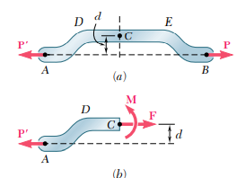  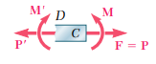

Example 1  Knowing that for the cast iron link shown the allowable stresses are $30 MPa$ in tension and $120 MPa$ in compression, determine the maximum force P that can be applied. | 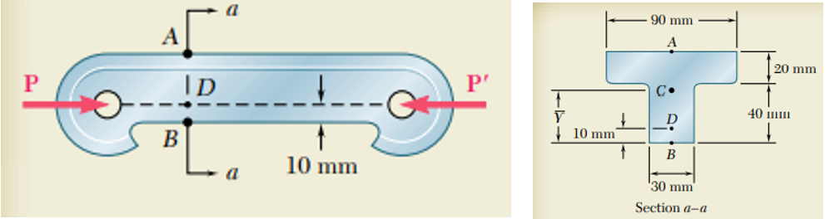

$A_{i}$ ${mm}^{2}$ $y_{i}$ mm $$A_{i}y_{i}$$  1. $$20×90=1800$$ $$50$$ $$90000$$  2. $$40×30=1200$$ $$20$$ $$24000$$  $${ΣA}_{i}=3000$$ $${ΣA}_{i}y_{i}=114000$$  $$\overline{y}=\frac{{ΣA}_{i}y_{i}}{{ΣA}_{i}}=38 mm$$ | 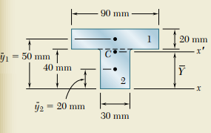  $$z$$
Moment of inertia of the cross-section about the neutral axis (centroidal z-axis)  $$I_{zz}=\left\{\frac{90×{20}^{3}}{12}+1800×{12}^{2}\right\}+\left\{\frac{30×{40}^{3}}{12}+1200×{18}^{2}\right\}$$  $$I_{zz}=868×{10}^{3} {mm}^{4}=868×{10}^{-9} m^{4}$$ | 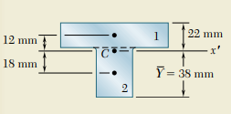  $$z$$
The line of action of $P$ is passing through point $D$ in the cross section which is $d=28mm$ below the centroid $C$. Transferring the force $P$ from $D$ to $C$ by applying two equal and opposite forces of magnitude $P$ at $C$, we can find the equivalent force-moment system at $C$.

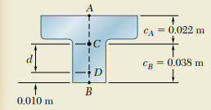  $$y_{A}$$  $$y_{B}$$ | 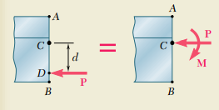
The moment $M_{z}=P×d=0.028P clockwise=-0.028P$
Now, we can see that the effect of $P$ acting eccentrically at $D$ is equivalent to a axial compressive force $P$ at $C$ and pure bending moment $M_{z}=-0.028P$
The uniform normal stress on the cross section due to the axial compressive force $P$ acting at the centroid,
$${{σ_{xx}}^{axial}}_{ }=-\frac{P}{A}=-\frac{P}{3000 {mm}^{2} }=-\frac{P}{3000×{10}^{-6} m^{2} }=-333P$$
The normal stress on the cross section due to the bending moment $M_{z}=-0.028P$ ${σ_{xx}}^{bending}=-\frac{M_{z}}{I_{zz}}y$
The stress at B where $y_{B}=-0.038 m,$ ${σ_{xx}}^{bending}=-\frac{\left(-0.028P\right)}{868×{10}^{-9} m^{4}}\left(-0.038 m\right)=-1226P$
The stress at A where $y_{A}=+0.022 m,$ ${σ_{xx}}^{bending}=-\frac{\left(-0.028P\right)}{868×{10}^{-9} m^{4}}\left(+0.022 m\right)=+710P$
Applying the principle of superposition, we can find out the net stress acting on the cross section.
$${σ_{ }}_{xx}^{A}=-333P+710P=+377P$$  $${σ_{ }}_{xx}^{B}=-333P-1226P=-1559P$$  The maximum tensile stress permitted is $30MPa.$  $$30×{10}^{6}=377P≫≫P=79.6×{10}^{3}N$$  The maximum compressive stress permitted is $120MPa.$  $$-120×{10}^{6}=-1559P≫≫P=77×{10}^{3}N$$ | 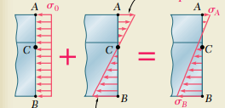  $$y$$  $$Q$$
The magnitude of largest force P that can be applied without exceeding either of the allowable stress is the smaller of the two values of P found out.
$$P=77×{10}^{3}N$$
$${σ_{ }}_{xx}^{A}=+377P=29 MPa ≪≫ {σ_{ }}_{xx}^{B}=-1559P=120 MPa$$
Note the shift in the neutral axis position.
$$\frac{{σ_{ }}_{xx}^{A}}{y}=\frac{{σ_{ }}_{xx}^{B}}{0.06-y} ≫≫\frac{29}{y}=\frac{120}{0.06-y} ≫≫y=0.0117 m=11.7 mm$$

Exercise 1  The vertical portion of the press shown consists of a rectangular tube of wall thickness $t=10 mm$ and outer dimensions $80 mm×60 mm.$ Knowing that the press has been tightened on wooden planks being glued together until $P=20 kN$, determine the stress at point $A$ and point $B$. | 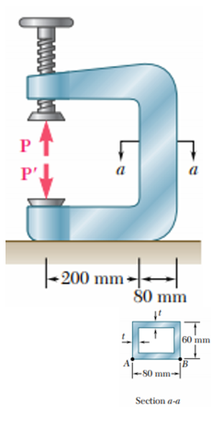
Exercise 2  Knowing that the magnitude of horizontal force is P=8 kN, determine the stresses at A and B. | 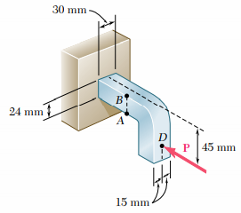

General case of eccentric axial loading
In the last section, we discussed about the eccentric axial loading in the plane of symmetry. Now, let us consider the analysis of axial eccentric loading not in the plane of symmetry. Consider a straight beam with a vertical axis of symmetry subjected to an axial force $P$ not in the plane of symmetry. |  | 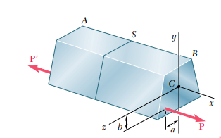
First, let us transfer the force $P$ to the plane of symmetry and then to the centroid.
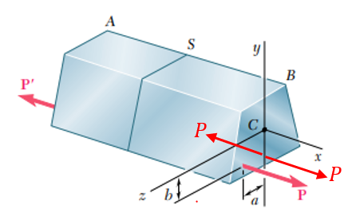 | 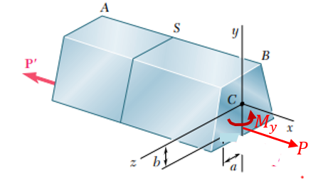 |  | The moment $M_{y}=Pa$  The moment $M_{z}=Pb$
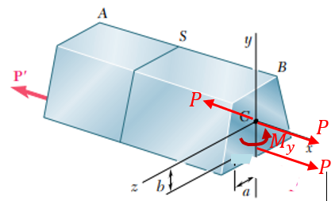 | 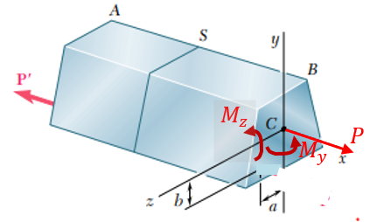 |  | 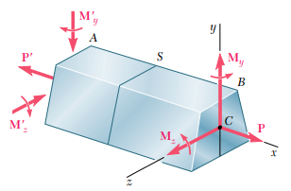
The net stress developed will be the algebraic sum of the stresses produced by the axial force P and the pure bending moments $M_{y}$ and $M_{z}$ (superposition).
$$σ_{xx}=±\frac{P}{A}±\left(\frac{M_{z}}{I_{zz}}y\right)±\left(\frac{M_{y}}{I_{yy}}z\right)$$

#Example 1  A vertical 480 kN load is applied as shown on a wooden post of rectangular cross section 80mm x 120 mm. Determine the stress at points A, B, C, and D. | 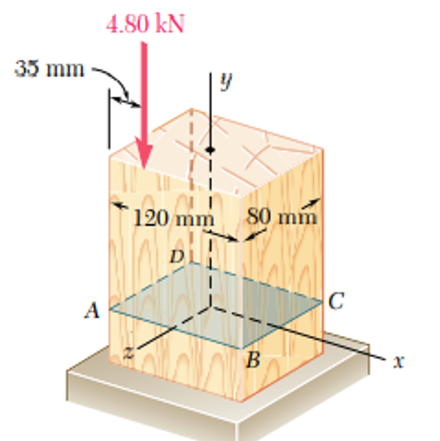
$$I_{zz}=\frac{0.080×{0.120}^{3}}{12}=11.52×{10}^{-6} m^{4}$$
$$I_{xx}=\frac{0.120×{0.08}^{3}}{12}=5.12×{10}^{-6} m^{4}$$
To begin with, transfer the force P to the plane of symmetry. The force will be accompanied by a couple of moment $M_{z}=480 kN×\left(60mm-35mm\right)=120 N.m$. Then, transfer the force to the centroid of the cross section. The accompanying moment is $M_{x}=480 kN×\left(40mm\right)=192 N.m$
 |   $$M_{z}$$ |   $$M_{z}$$ |   $$480 kN$$  $$M_{x}$$  $$M_{z}$$
The uniform normal stress produced over the cross section ABCD due to the axial force P,
$${σ_{ }}_{yy}^{Axial}=-\frac{P}{A}=-\frac{480×{10}^{3 }N}{0.120 m×0.080 m }=-0.5×{10}^{6} Pa$$
The normal stress on the cross section due to a moment $M_{z}=-120 Nm$,
$${σ_{ }}_{yy}^{bending}=\frac{{-M}_{z}}{I_{zz}}x$$
The normal stress at A, D due to the bending moment $M_{z}$, where $x=-0.06 m$
$${σ_{ }}_{yy}^{bending}=-\frac{-120 N.m}{11.52×{10}^{-6} m^{4}}×\left(-0.06 m\right)=-0.625×{10}^{6} Pa$$
The normal stress at B, C due to the bending moment $M_{z}$, where $x=+0.06 m$
$${σ_{ }}_{yy}^{bending}=-\frac{-120 N.m}{11.52×{10}^{-6} m^{4}}×\left(+0.06 m\right)=+0.625×{10}^{6} Pa$$
The normal stress on the cross section due to a moment $M_{x}=+192 Nm$,
$${σ_{ }}_{yy}^{bending}=\frac{{-M}_{x}}{I_{xx}}z$$
The normal stress at A, B due to the bending moment $M_{x}$, where $z=+0.04 m$
$${σ_{ }}_{yy}^{bending}=-\frac{192 N.m}{5.12×{10}^{-6} m^{4}}×\left(+0.04 m\right)=-1.5×{10}^{6} Pa$$
The normal stress at C, D due to the bending moment $M_{x}$, where $z=-0.04 m$
$${σ_{ }}_{yy}^{bending}=-\frac{192 N.m}{5.12×{10}^{-6} m^{4}}×\left(-0.04 m\right)=+1.5×{10}^{6} Pa$$

$${σ_{ }}_{yy}^{A}=-0.5×{10}^{6} Pa-0.625×{10}^{6} Pa-1.5×{10}^{6} Pa=-2.625×{10}^{6} Pa$$  $${σ_{ }}_{yy}^{B}=-0.5×{10}^{6} Pa+0.625×{10}^{6} Pa-1.5×{10}^{6} Pa=-1.375×{10}^{6} Pa$$  $${σ_{ }}_{yy}^{C}=-0.5×{10}^{6} Pa+0.625×{10}^{6} Pa+1.5×{10}^{6} Pa=+1.625×{10}^{6} Pa$$  $${σ_{ }}_{yy}^{D}=-0.5×{10}^{6} Pa-0.625×{10}^{6} Pa+1.5×{10}^{6} Pa=+0.375×{10}^{6} Pa$$ | 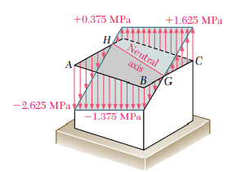

Exercise 1  The tube shown has a thickness 12 mm. Determine the stresses at points A, B, C, and D | 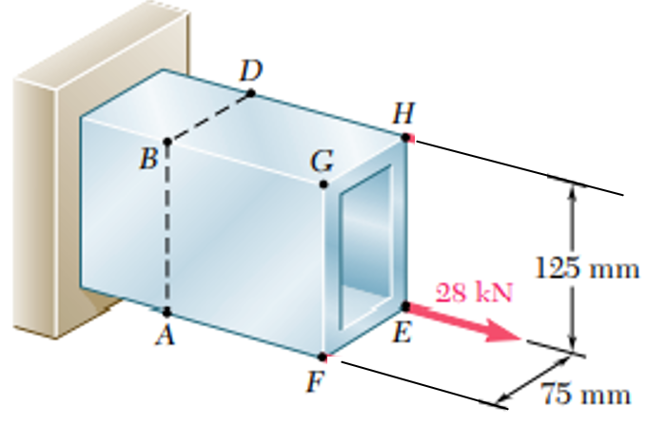  C

- Mechanics of Materials, 2/e, J. M. Gere & S. P.Timoshenko, CBS Publishers.
- Mechanics of Materials, 6/e, F.P. Beer & E. R. Johnston, McGraw Hill
- Engineering Mechanics of Solids, 2/e, E. P. Popov, Pearson Education Asia.
- Mechanics of Materials, 9/e, R. C. Hibbeler, Prentice Hall.

